Lab 4: Tables, Data types and Loading Data

1. Activate Notebook

1. Create table with necessary data types

1. Locate the new table created

1. Rename table or alter its location

1. Preview data

1. INSERT data

1. Select \* on new table

1. Select \* variations

1. Select \* variations

1. Insert 2 more rows

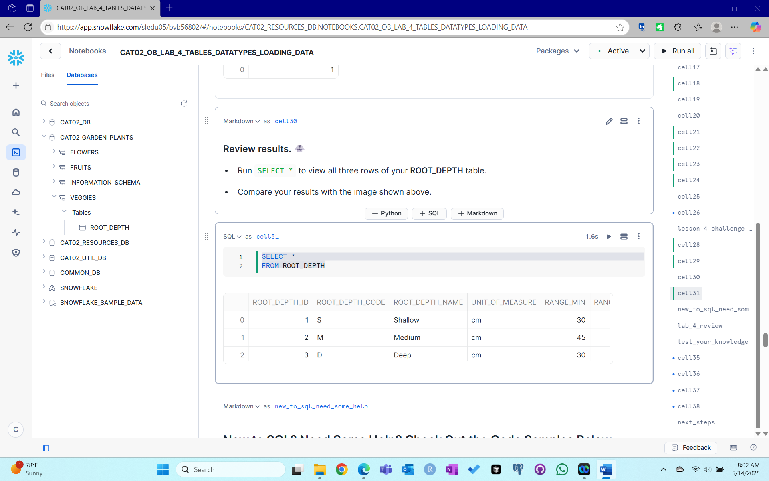

1. Test your knowledge

1. End lab session

Summary :

In this lab, we focus on tables and data types. We create a table with number and text datatypes defined for the columns. The table’s name or location can be altered. Viewing the definition makes us realize that the table shows TEXT columns as VARCHAR. We use INSERT INTO statements to load data. We also explore Select \* variations to refine our search. The lab ends with answering the quiz questions and deallocating resources.